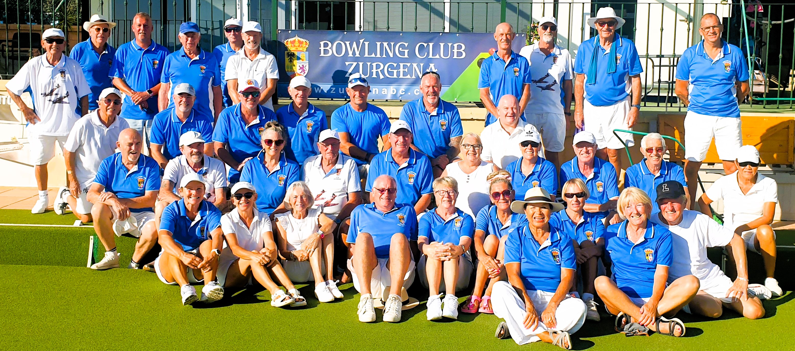

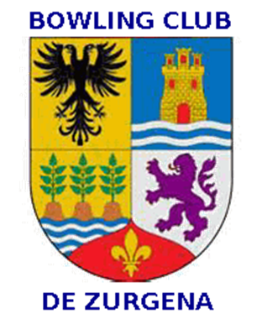

Issue 12
November 2025
‘THE BIAS’

President: Adrian Leitch Tel. 711 03 57 18 Club Captain: Donald Garden 722 26 13 81

PRICE BROWN TROPHY MATCH
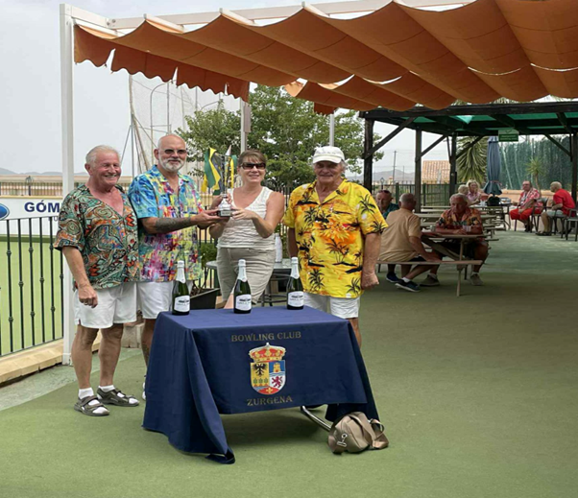

The victorious team captained by Wal Walton, with trophy presented by Elaine.
What a fabulous day of bowling and camaraderie at our Price Brown Trophy funday. 40 bowlers of all abilities became 14 teams who played a tough round robin of 18 ends in 3 sets of trips.
The final result was very close with only 4 points between the top 3 teams.
Congratulations to the winners Ian 'Wal' Walton, Martin Harris and Brian Mason.
Members who took part and supported the event enjoyed the relaxed atmosphere with most dressing in the Hawaiian theme.
It was a great team effort with members setting up, manning the teahut, running the plancha, hosting games, a raffle and taking photographs.
We had Graham keeping us entertained all day with his music, catering for all genres.
Our sponsors Price Brown and Elaine donated a lovely hamper and gave each member there a gift. The hamper raised 180€ in a dutch auction, the winning bidder being Laurann Walton.
Well done to Dez O'Connor and Wal Walton for the overall organisation of the day in their new positions within the committee as Social Sec and Competition Sec respectively.
More photographs to follow

More photographs Price Brown fun day
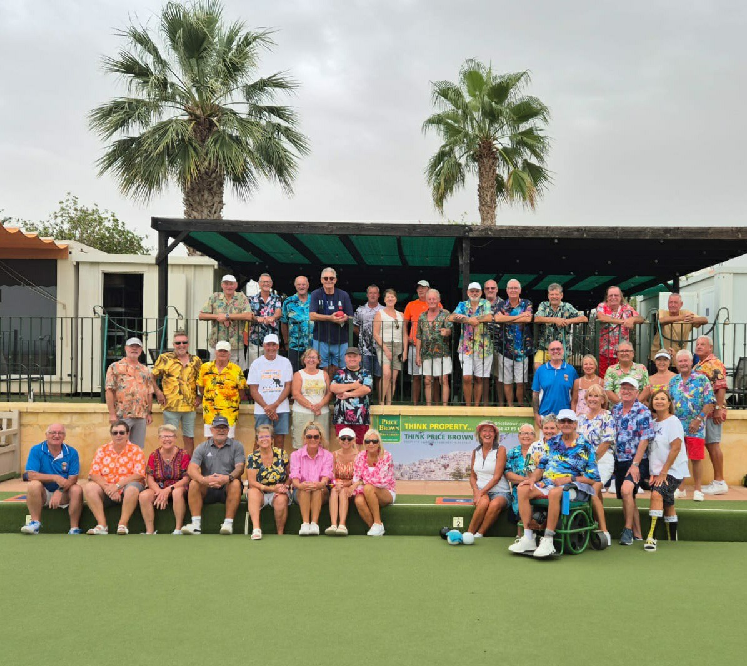 | 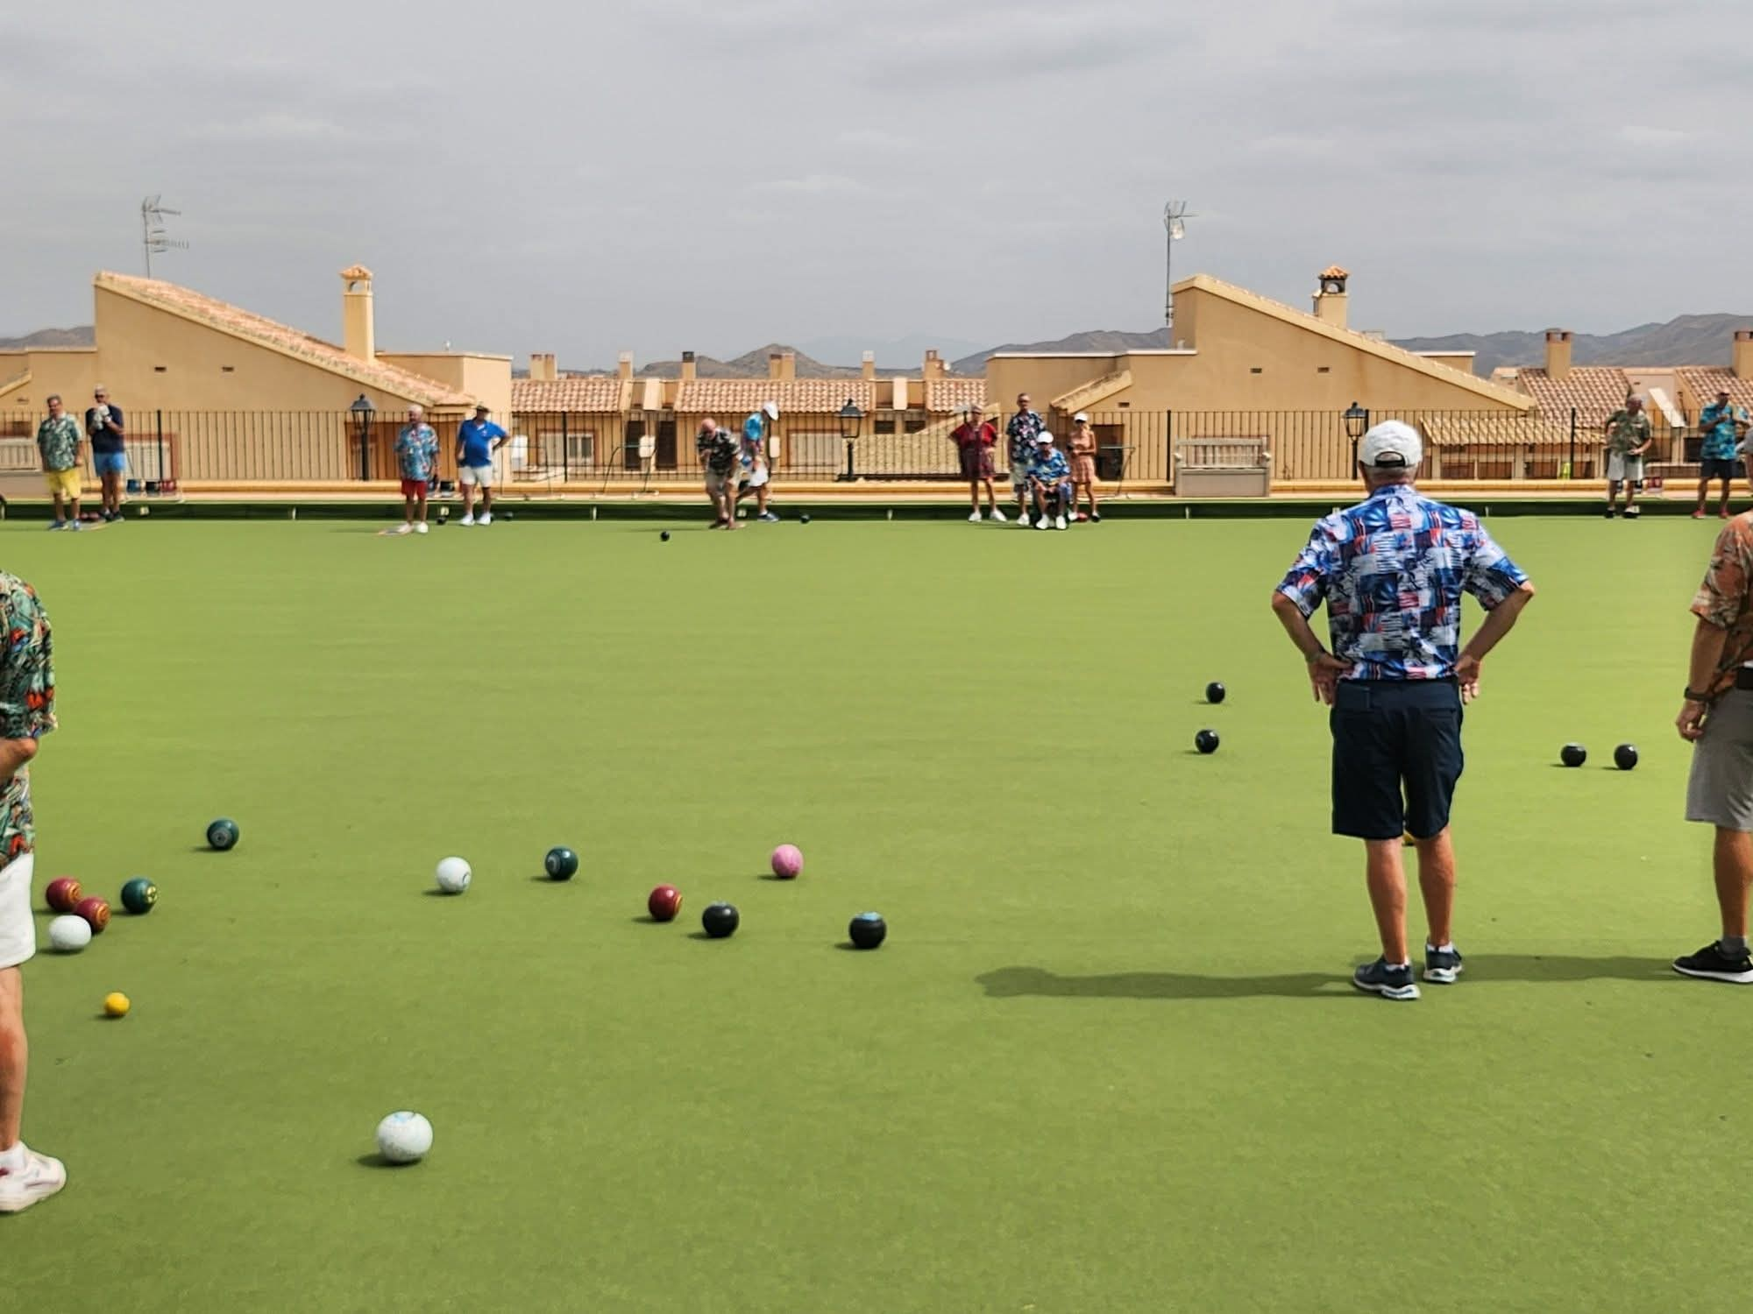
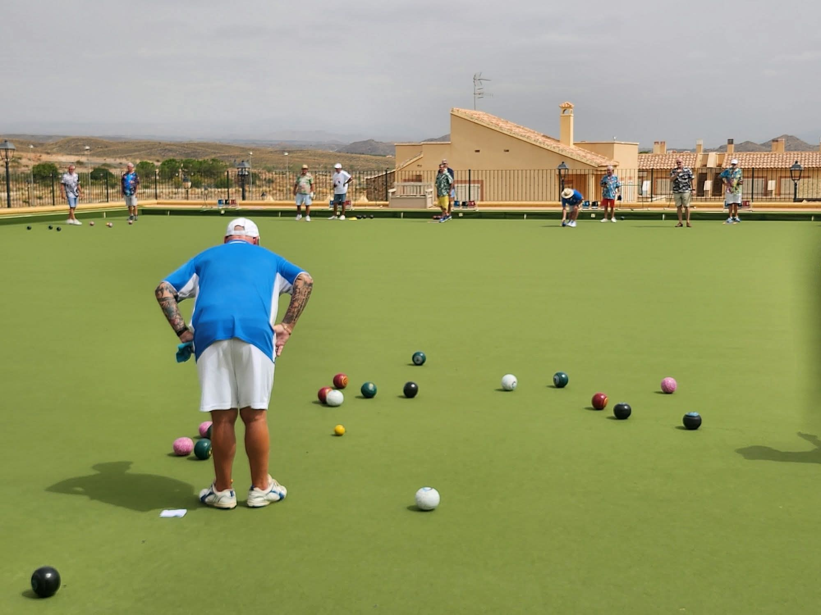 | 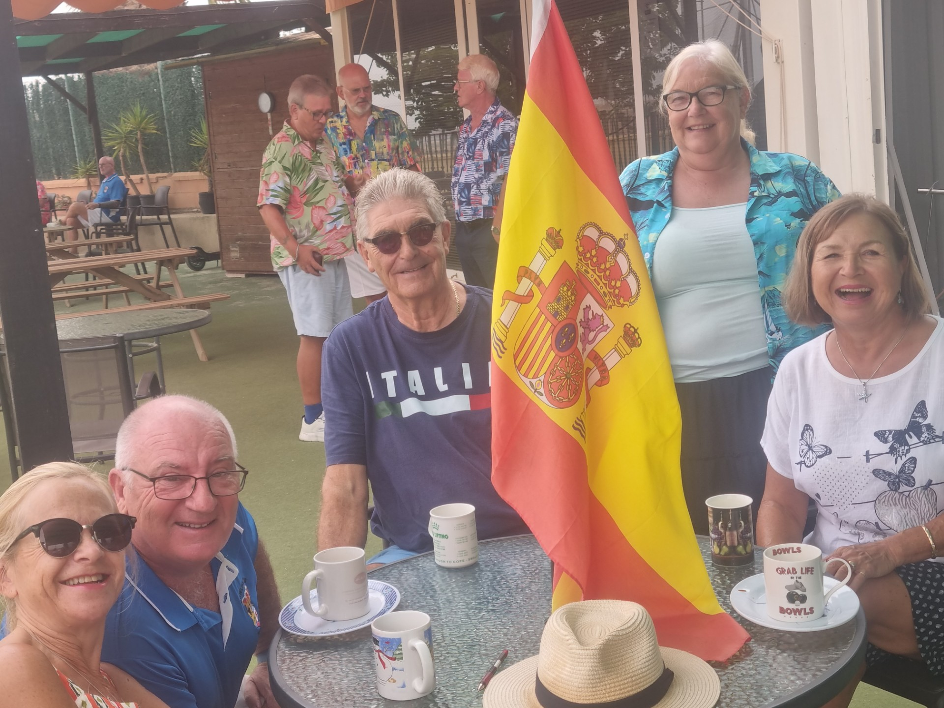
The Non- Winners Singles Trophy
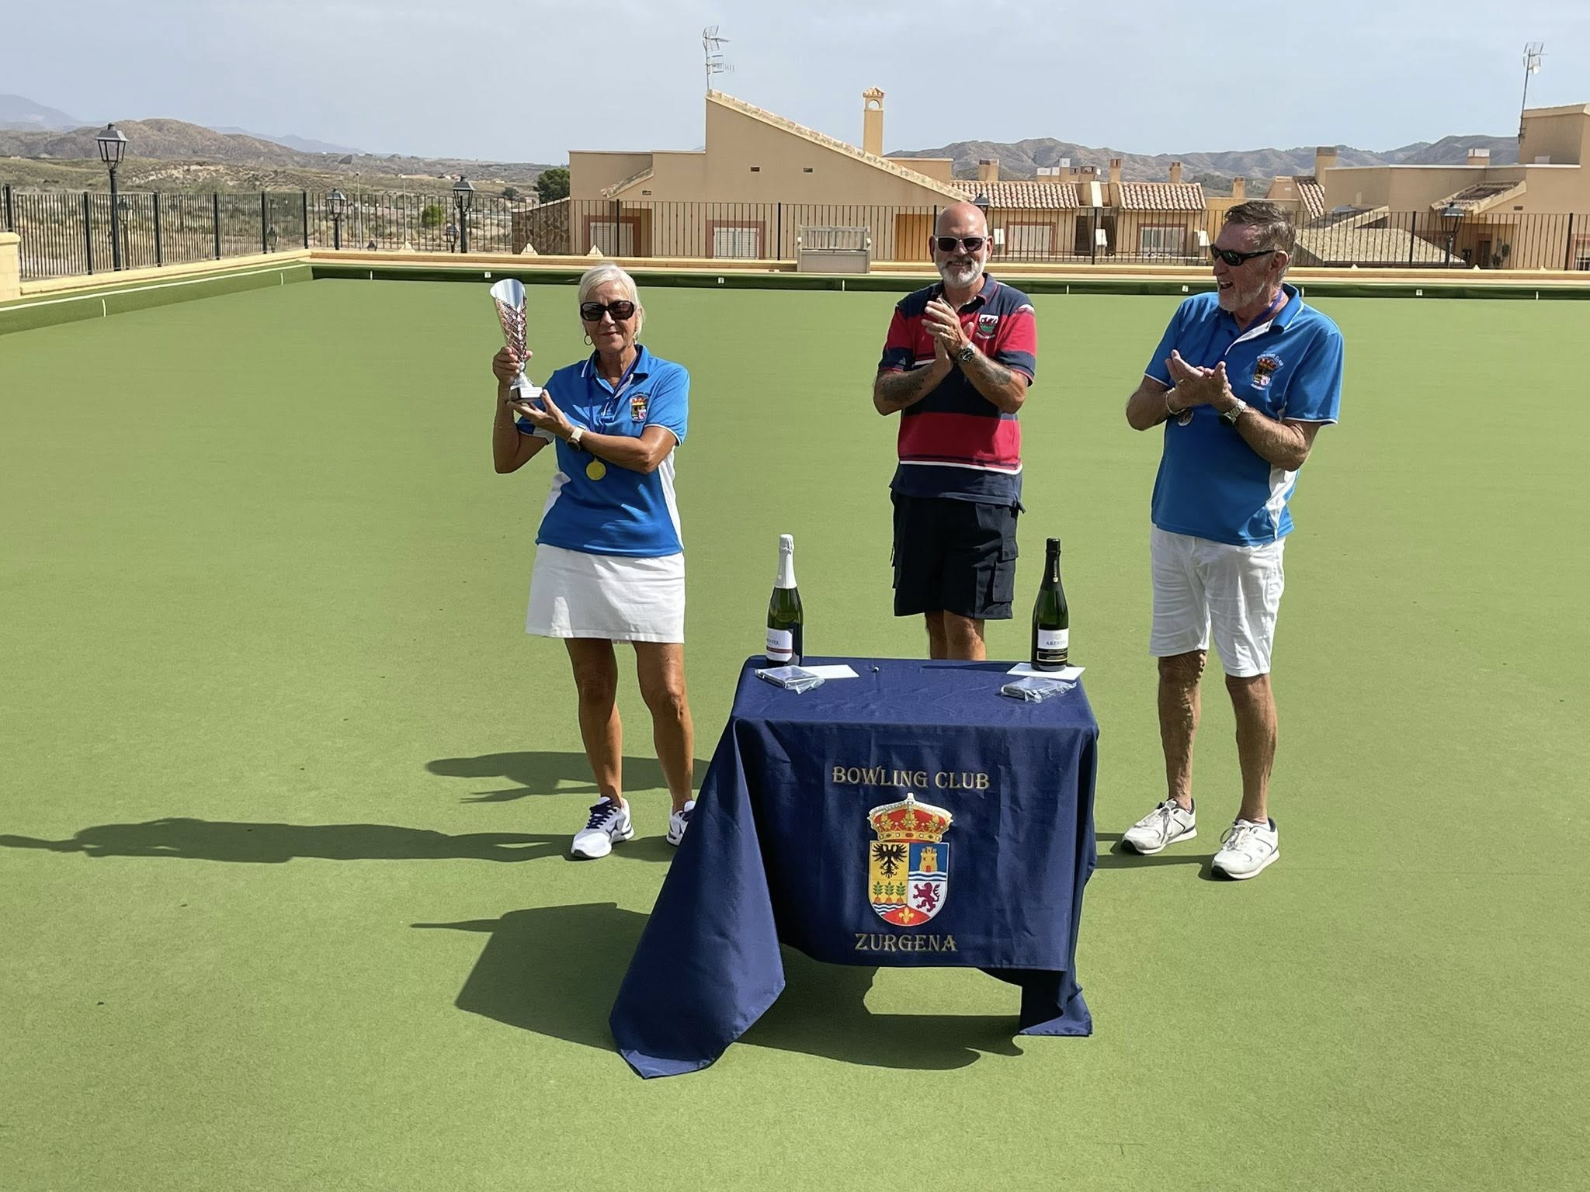

This new competition was for all members who hadn’t won a singles competition in the last 5 yrs and gave them a chance to compete. It was the first to 21 points after two trial ends in a straight knockout format and there were some very close and hard-fought matches over the four days.
The final between Susie & Malcolm Darby was well supported and those that came to watch were treated to a very entertaining match that saw some excellent bowling from both players.
Malcolm set the early pace, pulling out a 5 shot lead after 5 ends. Susie fought back with some very consistent bowling through the middle of the match resulting in a lead of 20 shots to 10 after 17 ends. Despite a late comeback from Malcolm, it was Susie that ran out as the victor with a final score of 21 to 15 after 21 ends.
Many Congratulations to Susie. Commiserations to Malcolm for a great match and there is always next year!?

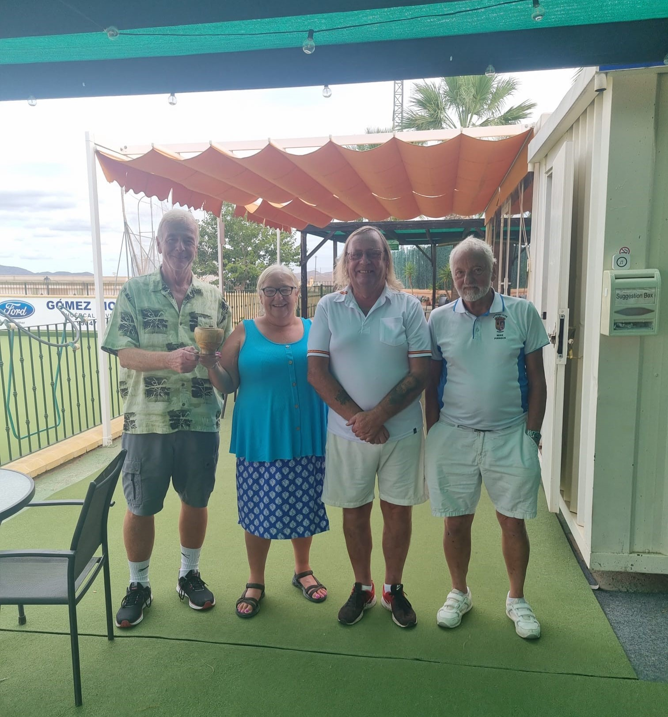  Disappointing turnout for our Bowl and Quiz afternoon. Only 1 trip for the bowling of 10 ends. Luckily a few more turned up for the quiz hosted by Steve Way on behalf of Dez. 3 teams competed for the winners cup with David, Carol, Mike and Rob winning.  Overall those that participated had a really great afternoon, |  |  | 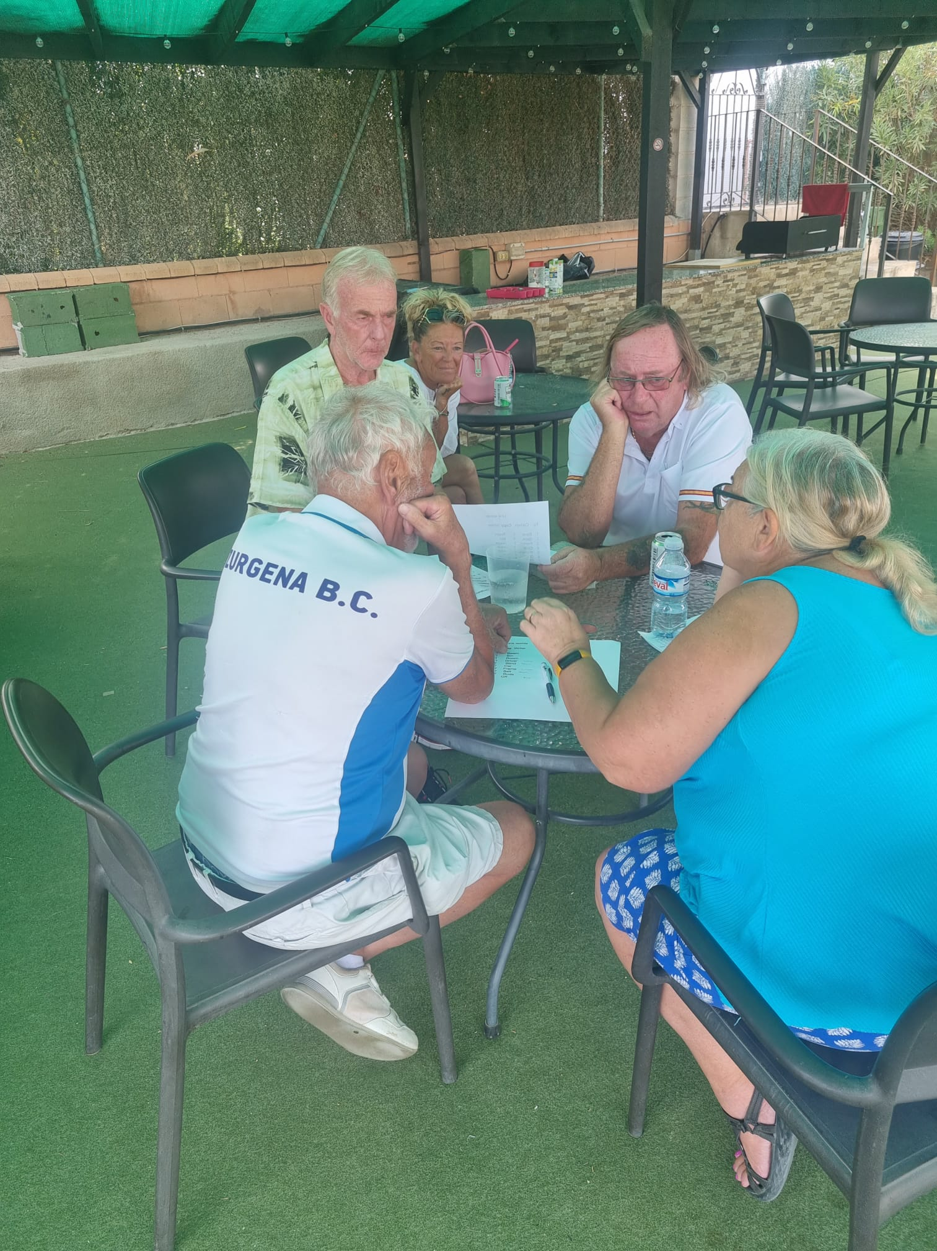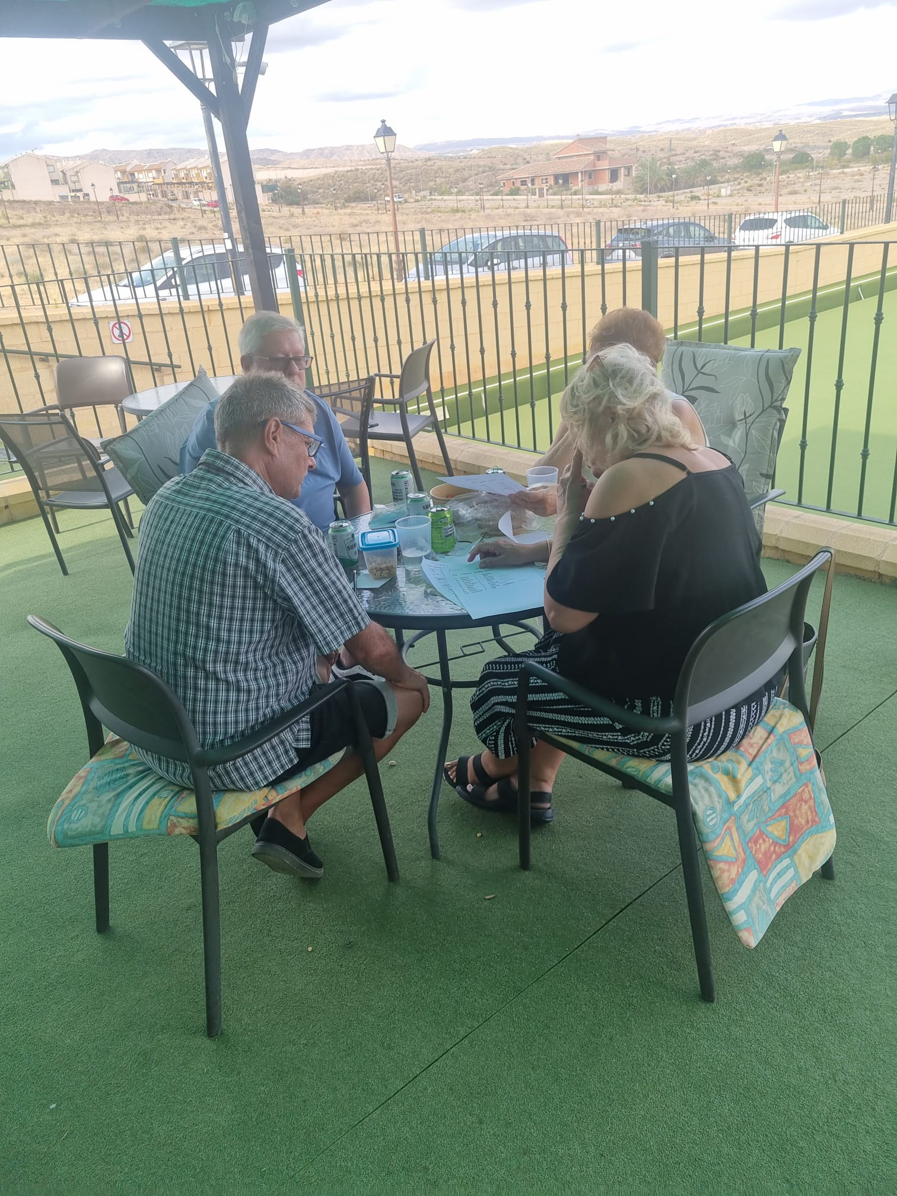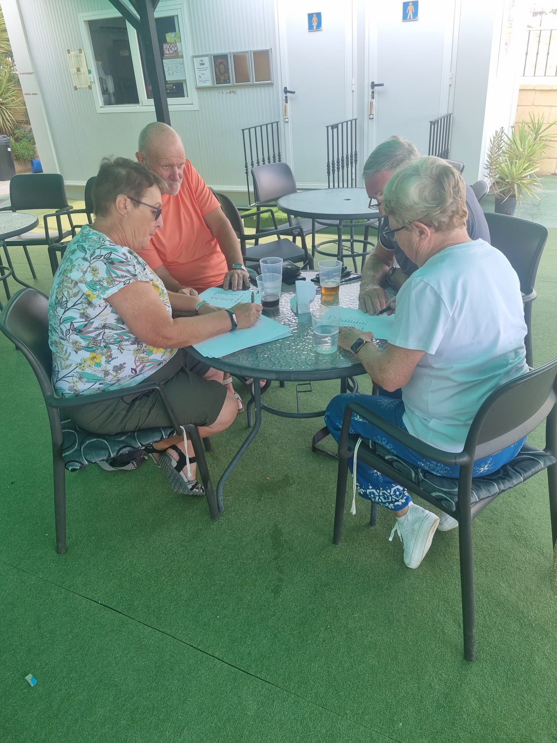

QUIZ WINNERS QUIZ PARTICIPANTS

Quiz Participants

MIXED PAIRS COMPETITION

What a fabulous final to our Mixed Pairs competition. Tricia Dugmore and Steve Daniel went into an early lead taking 5 on the 1st end so by end 3 they were leading 7-0. Donald and Leanne Garden then took the next 5 ends to lead 11-8 by end 8. The match continued like this, toing and froing until end 17 and Donald and Leane were leading 20-18, but Steve and Tricia managed to take 2 the last end making it a draw. An extra end played and the umpire was called to measure, it was that close but victory went to Steve and Tricia by 1 point. 21 v 20
Congratulations to both teams for an excellent competition and especially Steve and Tricia on their win. Commiserations to Donald and Leanne but what a match.
Thanks to Rich Brimble for organizing this Mixed Pairs competition
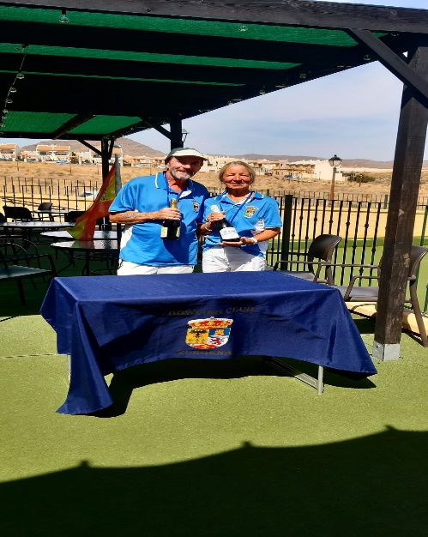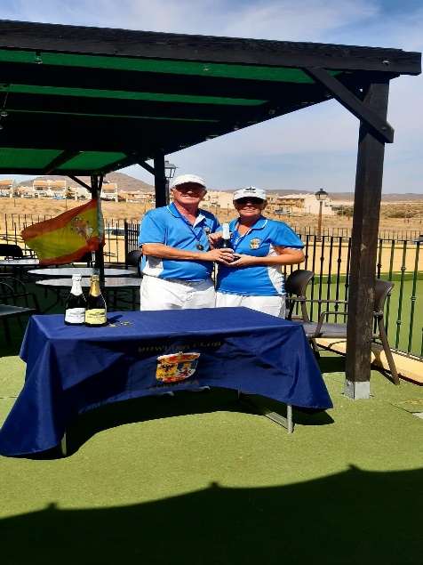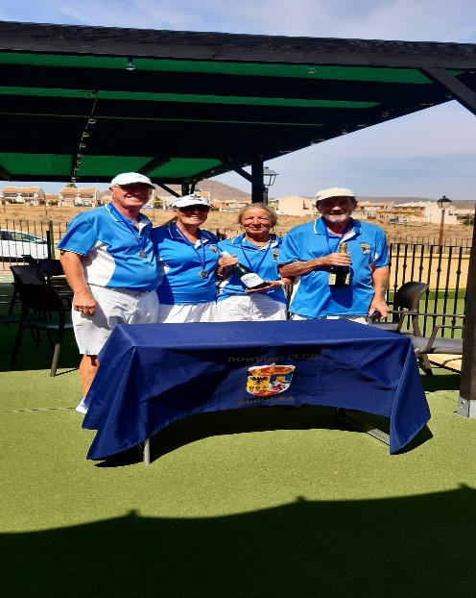
MENS PAIRS COMPETITION
The club members and guests were treated to some excellent bowling as the fortunes in all three games ebbed and flowed during the Men's Pairs quarter finals
Paul Day & Ray Malt got off to a flying start against Jason Wilson & MickRyan and were leading 13 - 0 after four ends. But Jason and Mick fought back to reduce the deficit to 16 - 11. Paul & Ray held their nerve though and won the game 21 – 14.
Rich Brimble & Colin Appleton took an early lead against Derek Strong & Steve Daniel but after 11 ends the match was tied at nine all. Taking the last 5 ends Del and Steve took the win 22-11.
The final match between Mike Bray & David Arnold and Roy Alderslade & Mark Cavell was a closely fought affair with the lead constantly changing hands and rarely more than two shots between them, however seven shots at the fifteenth end proved decisive for Mike & David as they went through to the semi-finals with a 22 - 13 win.

The Zurgena Men's Pairs semi-finals threw up two very contrasting but hard fought games for the watching members and guests to enjoy.
On rink 3, Paul & Ray continued where they left off yesterday to take a commanding 9 - 2 lead over Malcolm Derby & Malcolm Barber after eight ends, but the Malcolms fought back to reduce the deficit to 10 - 8. It served as a warning for Paul and Ray to up their game which they duly did, to run out comfortable 21 - 9 winners with an end to spare.
The other semi-final saw Derek & Steve taking on Mike & David on rink 5. Del and Steve got off to a flying start chalking up ten shots without reply in the first six ends, but Mike and David had a great comeback, and after sixteen ends the scores were tied at thirteen shots apiece. Del and Steve picked up one shot to take the lead going into the last end and another two shots saw them through to the final 16 – 13

The Zurgena Men's Pairs Final between Derek & Steve against Paul & Ray turned out to be a very one-sided affair.
Despite playing so well in their previous two games to get to the final, Paul and Ray struggled to find their line and length from the start as Del and Steve raced into a 7 - 0 lead after just three ends including a five at the second.
Paul and Ray got on the scoreboard at the fourth end with a single, but from then on Derek and Steve totally dominated, constantly drawing closer to the jack and picking up twenty shots in the next eight ends to go into a commanding 27 points to 1 lead. Another single for Paul and Ray at the thirteenth wasn't enough to change matters sufficiently, and they conceded after thirteen ends to hand Derek and Steve a well deserved win and the title of Men's Pairs winners for 2025. 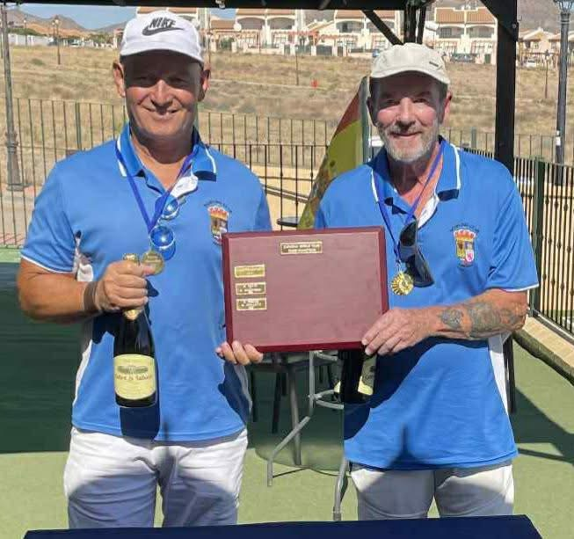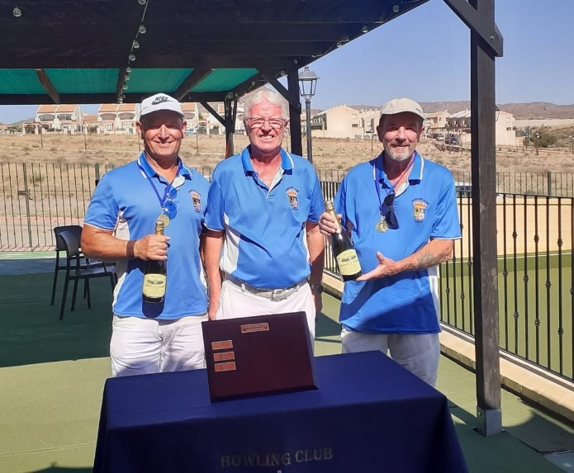
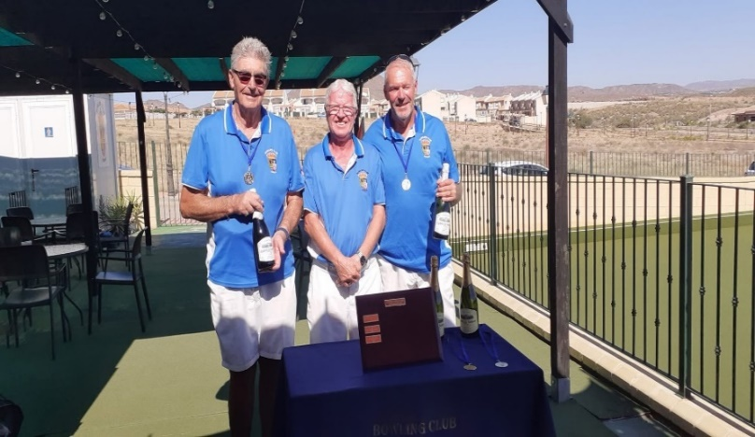
The runners up of the Mens Pairs Competition
WINDSOR FRIENDLY 13TH OCTOBER 2025
Everyone had a fabulous day in our friendly match against Windsor BC. They were on their annual trip from Wales to the sun of Almeria, staying in Mojacar to enjoy bowling in local clubs.
On arrival they were happy to find Colin on the plancha offering bacon butties or burgers or a mixture thereof so play started a little later than planned, especially as we had to have a group photograph from both sides. All 8 rinks in play, in glorious sunshine, the 2 teams battled hard in their respective trips. Well done to their team captain Sue who managed to secure a win but it was Zurgena who were victorious overall, taking the other 7 rinks. Afterwards it was drinks all round and general chit chat with Windsor commenting on how friendly our little club is.
Well done to all our members who played and a big thank you to Colin (who jumped in last minute to do the plancha) and a huge thank you to Dez and Julie who worked very hard manning the tea hut.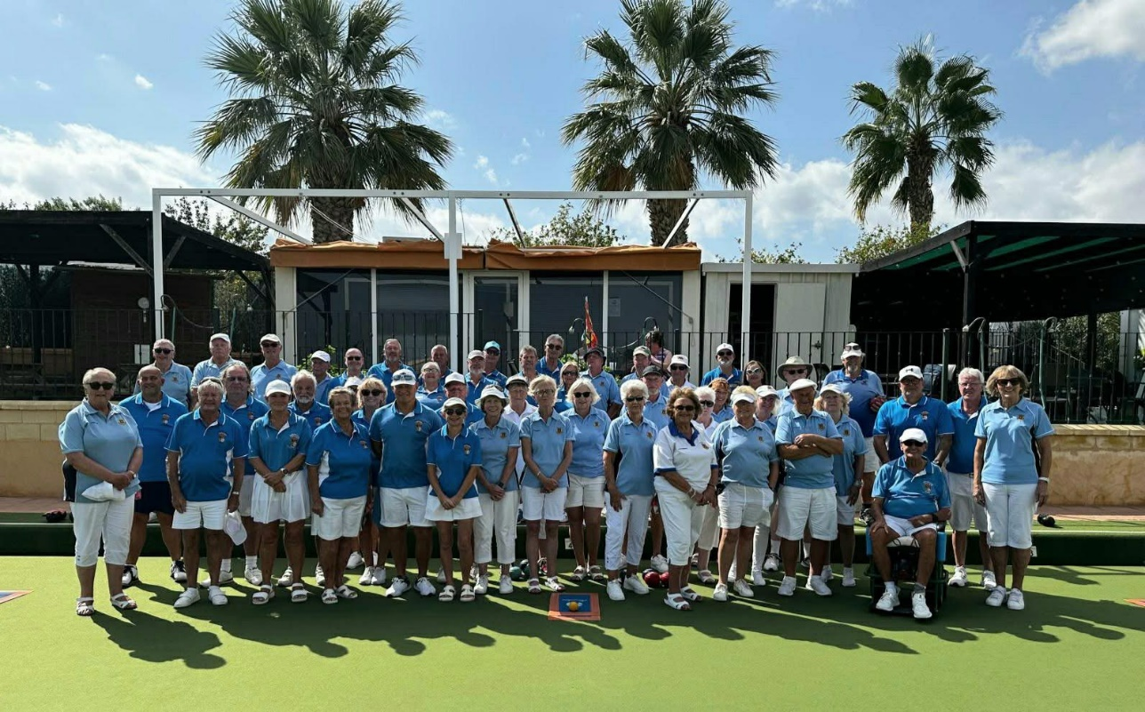

MIXED SINGLES COMPETITION
A great finale to the Mixed Singles Competition!
Mick Ryan set the early pace and looked set to make it a one-sided final, however Malcolm Darby had other ideas, and the comeback was on! He chipped away to reduce the lead back to 4 shots before Mick was eventually victorious. Congratulations to Mick on winning the Mixed Singles trophy!
However, congratulations are due to both players for a compelling final which entertained a superb crowd representing over a third of the membership who were treated to some great bowling. I know the players appreciated the level of support that they both received from a very appreciative crowd.
As always these competitions require considerable support to run smoothly, as mentioned by Ade at the presentation, but thanks again to all those who helped out over the last five days with setting out the Green, marking and running the tea hut, particularly to Donald & Rich B for their continued help
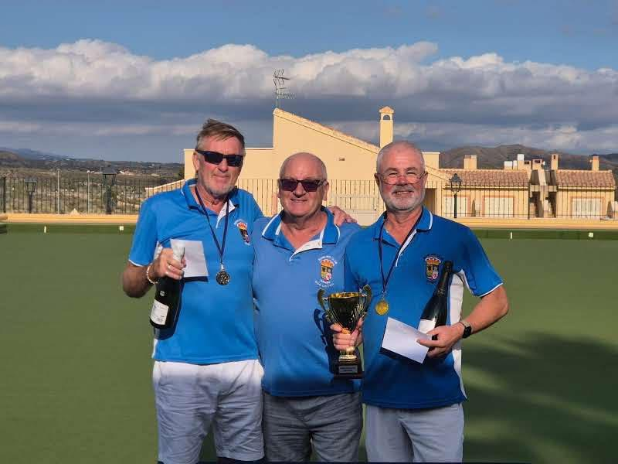
Mixed Singles Winner Mick Ryan with Runner-Up Malcolm Derby and President Ade Leitch
COMMITTEE NEWS
Please welcome and give your support to the following member who has volunteered to fill a position on the Management Team and General Committee.

Vice President: Colin Appleton email: cgappleton@live.co.uk
Thank you Colin

NEW MEMBERS
Please give a warm welcome to Dave Leslie, Gavin and Maz Sutherland who are new to bowling, and to Gloria and Bob Hammett who have joined us from Almeria Lawn Bowling Club.

