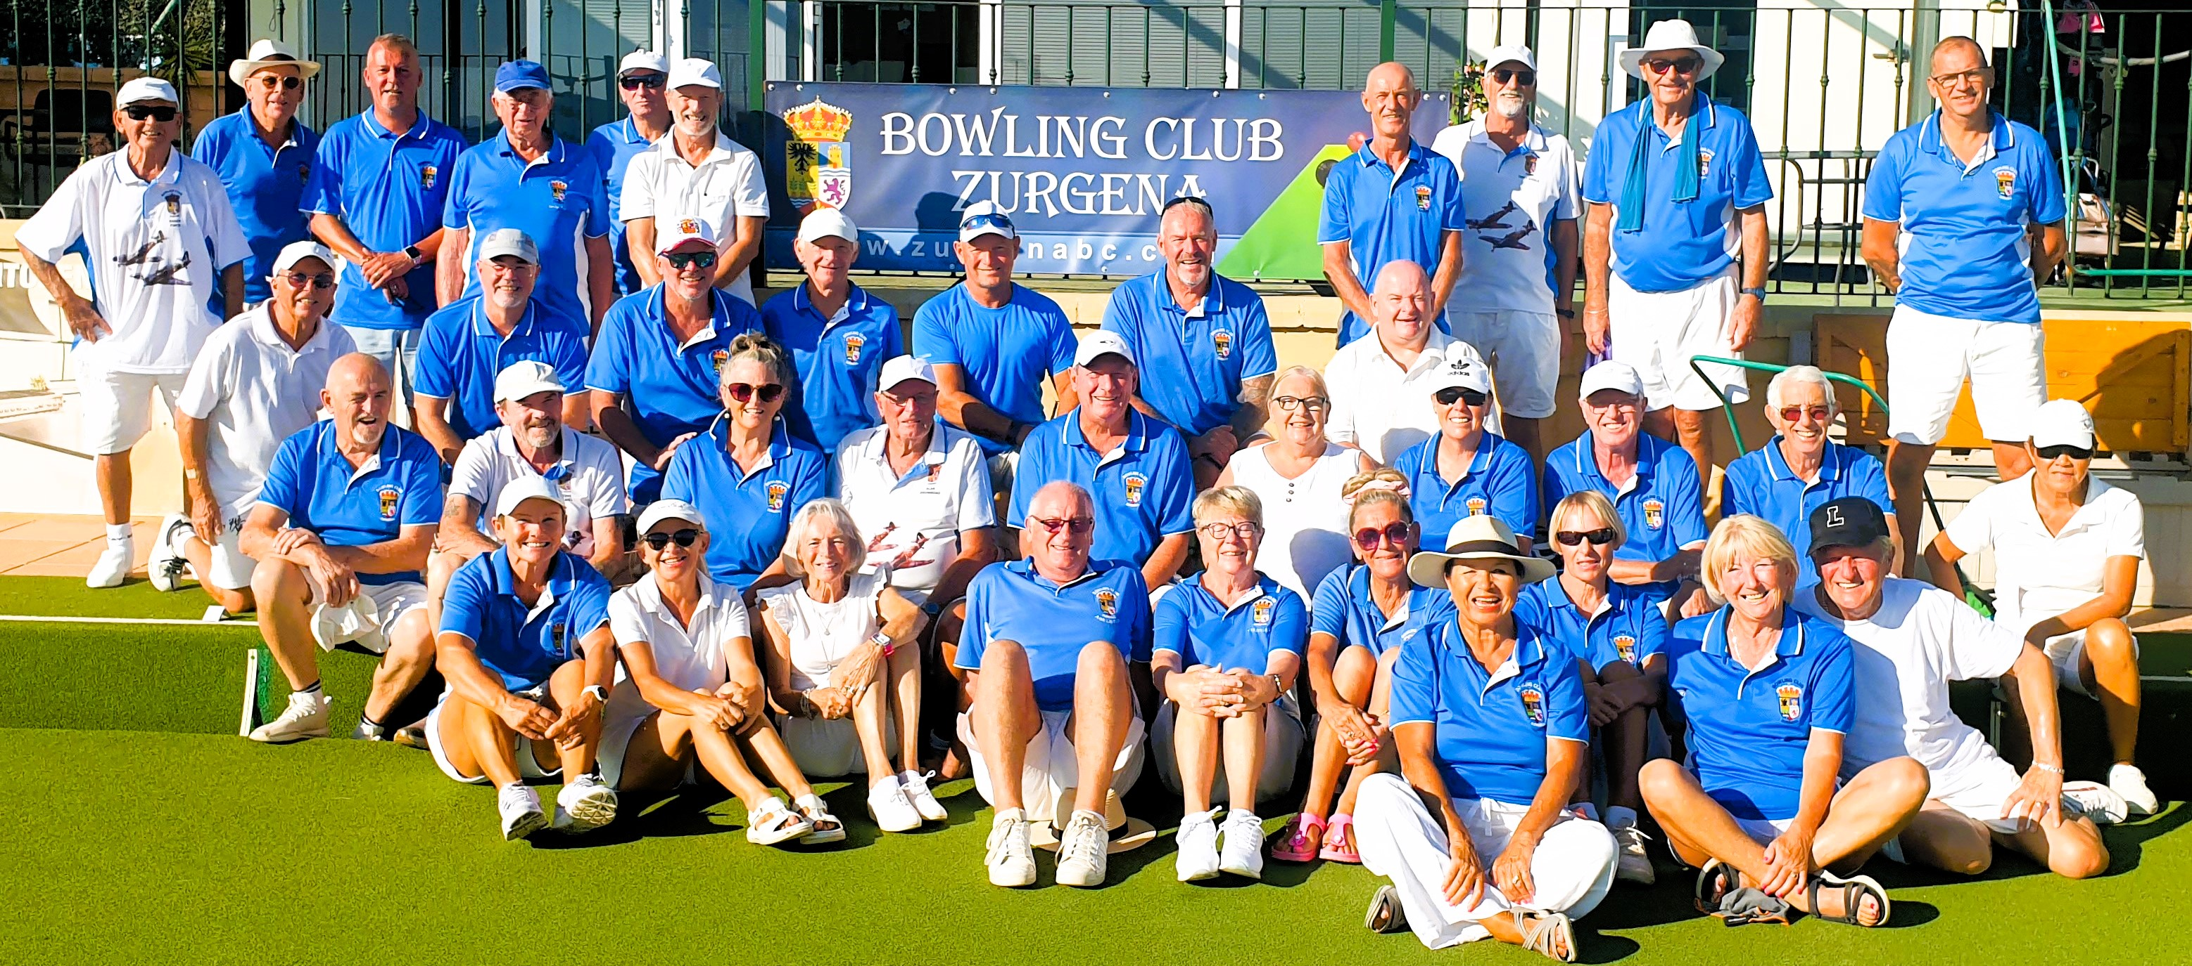

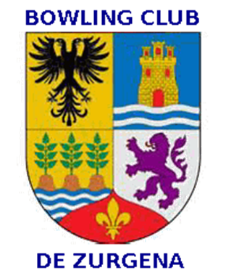

Issue 13
January 2026
‘THE BIAS’

President: Adrian Leitch Tel 711 03 57 18 Club Captain: Donald Garden 722 26 13 81 81
Late Halloween Funday
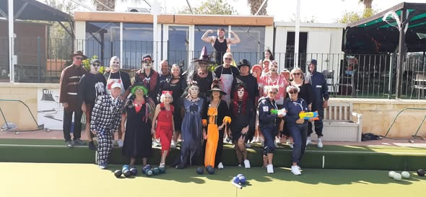

What a motley crew
What a fabulous day of bowling and camaraderie at our Late Halloween
Funday.
Members dressed up in their finest Halloween costumes and supported the
club whilst having some fun.
The day began with bacon sandwiches while tags were put in. Then it was
4 trips playing 10 ends. There was ghostbusters, skeletons, playing
against witches and axe murderers.
The winning team with 16 points goes to skip Steve Way, 2nd Tammy Wilson
and lead Steve Pears. Well done to them and the other players
After bowls Ade, chose Paul Day as the best fancy dress and duly supplied
him with a bottle of brandy. After sausage rolls and burgers amidst the general
socialising there were games,stand up sit down bingo and play your cards right,
music and songs.
Thanks go to Dez and Julie for the fab decorations and running the plancha.
To Steve for photos and running the teahut. To Carol for also running the teahut
and hosting the games. To John for providing us with music all day and ending
the day with some great singing.
The greatest thanks go to our fab core of members who turn up, make the effort
in costume and thoroughly enjoy themselves. All together a fabulous day.

More Photos
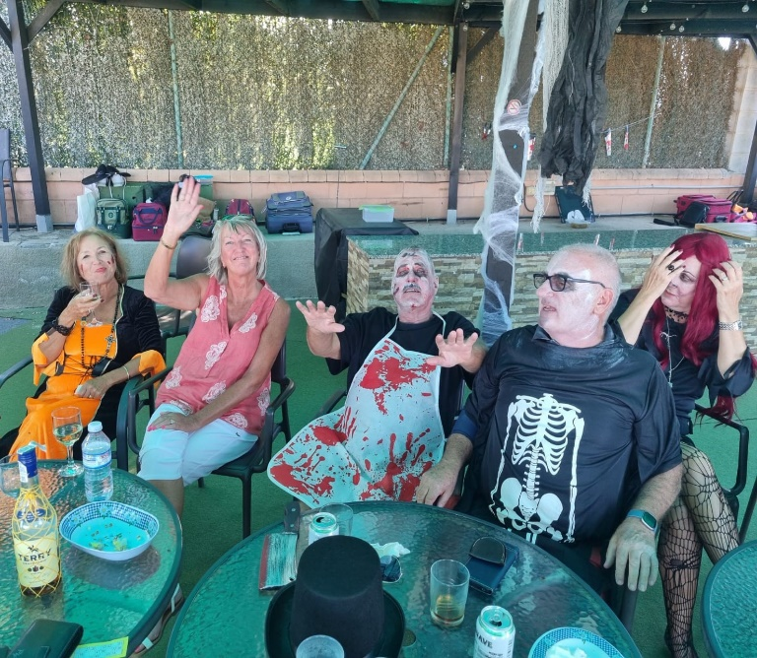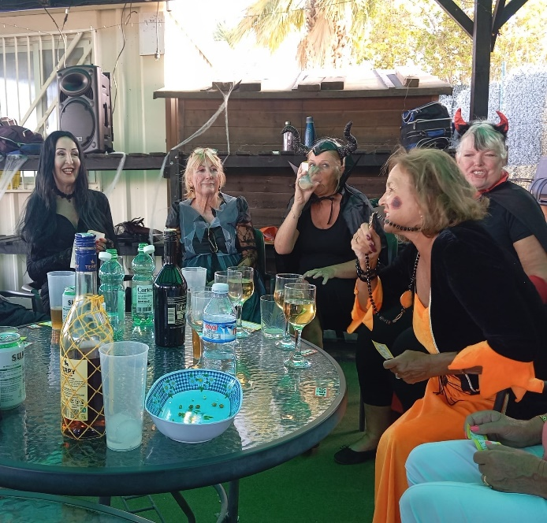

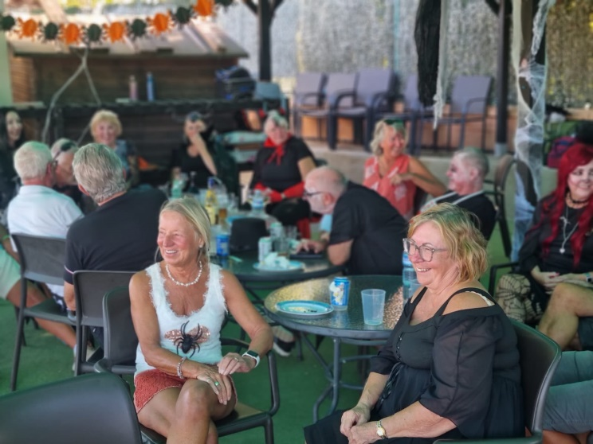
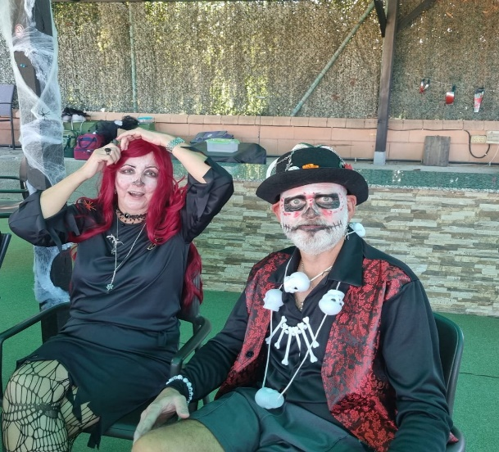

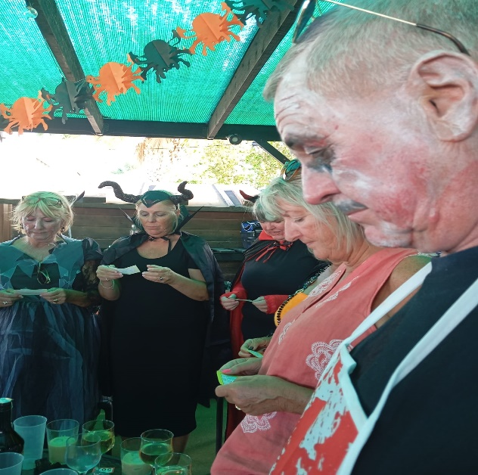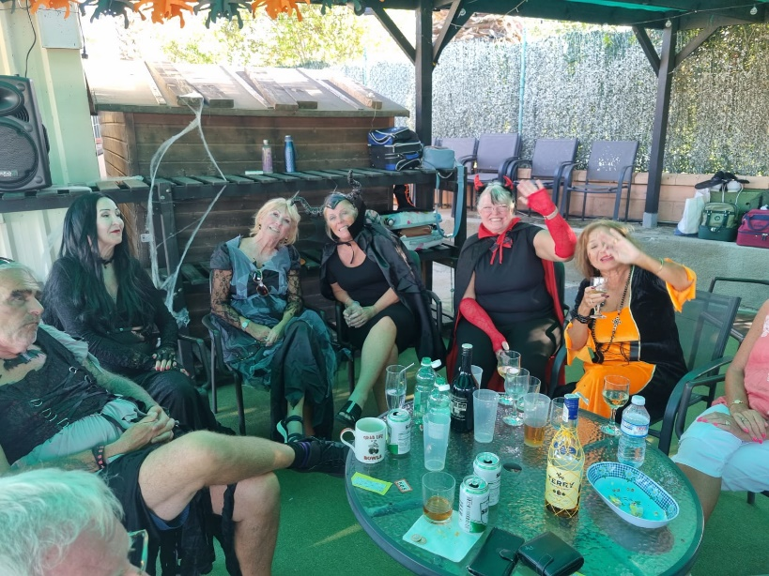

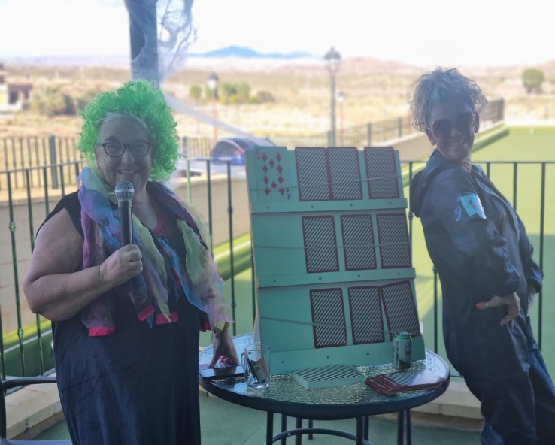 | 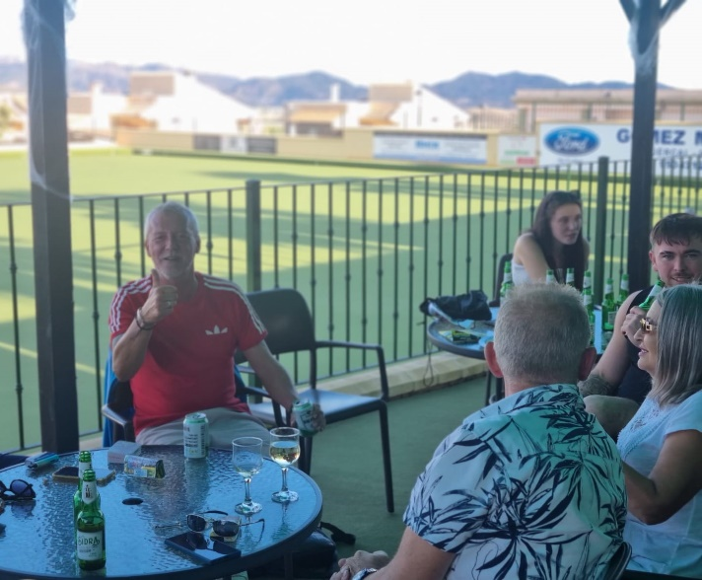
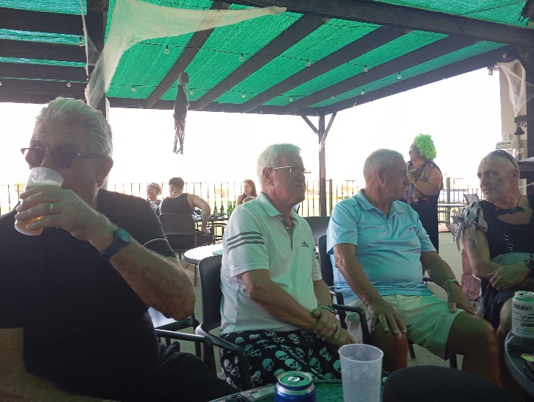 | 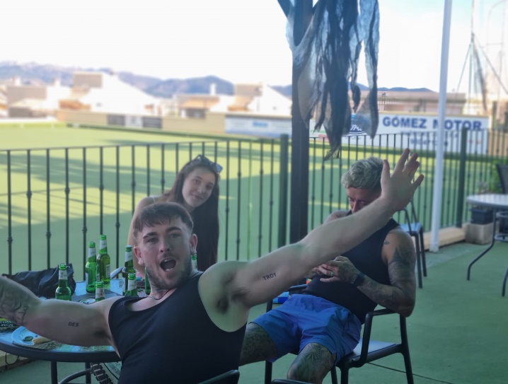

Remembrance Day 2025
A few members of the club attended the Remembrance Day service at the New Bar International. A poignant service which was made more special by the inclusion of a Spanish Priest blessing the Wreath laid and some Spanish Bomberos and town hall personnel marching with the veterans.
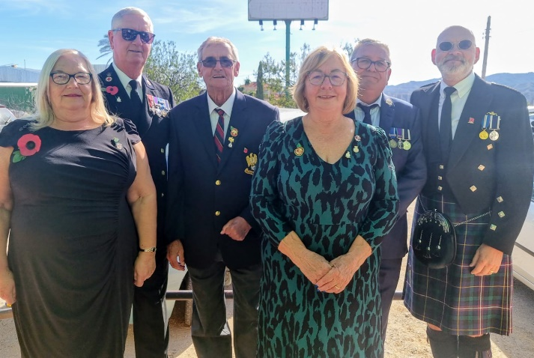

Drawn Trips Competition 14th-17th November

11 teams took part in this new competition with 6 teams playing on the Friday and the 3 winning teams joining the remaining 5 teams on the Saturday. The wind was horrendous with more storms and rain forecast over the weekend but players battled on.
Quiz Participants

On Monday the final commenced between Tammy, Malcolm D and Wal and Lorraine, Linda and Judy. The rain also started and spectators ended up huddled in the clubhouse as the teams battled on. Reluctantly two 20 minute breaks were taken in a bid to beat the rain but eventually the game was postponed after 12 ends with a scoreline of 15-10 to Wal’s team.
The match reconvened a week later with improved weather and the last 6 ends were dominated by the ladies resulting in a 21 – 18 win for Lorraine, Linda and Judy. Well done to them and commiserations to Wal, Malcolm D and Tammy.
Drawn Trips Winners
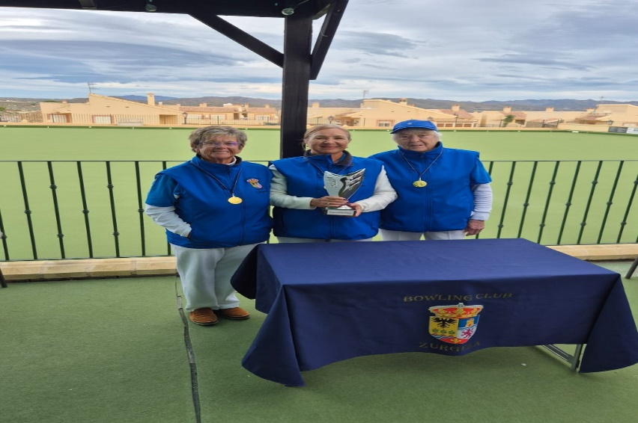
Lorraine Malt (Lead) Linda Lester (2nd) and Judy Abel (Skip)
Drawn Trips Runners Up  Tammy Wilson (Lead) Malcolm D (2nd) Ian “Wal” Walton (Skip)  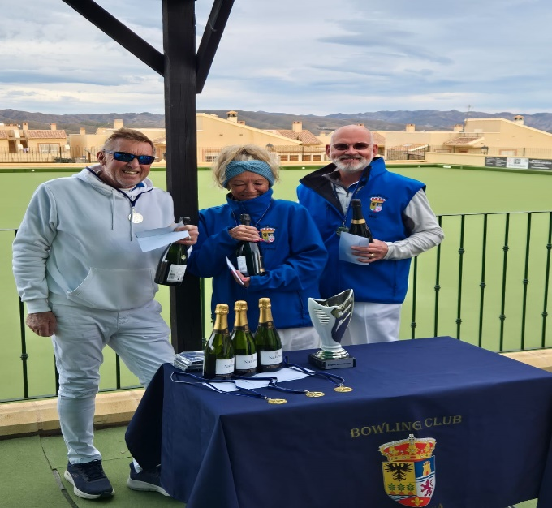 | Drawn Trips Finalists  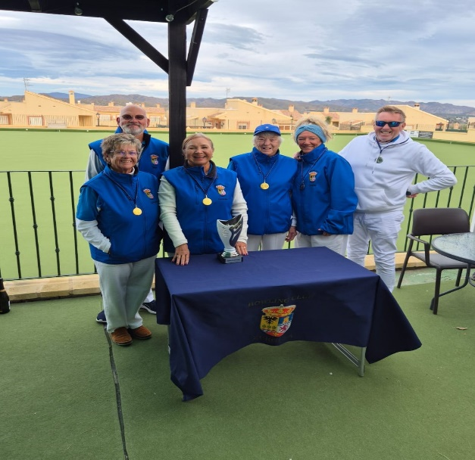

FAB Ladies Pairs
Zurgena was chosen by the FAB to host the Ladies Pairs Competition in November
Four of our ladies entered Linda Lester and Judy Abel and Gill Appleton and Susie Derby.
Congratulations to Gill and Susie who got through to the Semi Final.
The winning pair were ladies from Indalo BC. Thanks go to our club captain Donald for his
hard work and effort running this competition.

FAB Mens Pairs
This was held at Cabrera BC and we had Malcolm Derby and Steve Daniel flying the flag for Zurgena. Unfortunately they didn’t progress in the competition The winning pair were B Pinder and P Cartwright.

Alfoquia Plate Handicap Pairs 2025
Donald presided over this competition whilst our comp secretary enjoyed the cooler weather in the UK. He did a fabulous job as club members and guests were treated to some excellent bowling as the 12 teams were whittled down over four days to 2 teams. The final was between Mick Ryan and Jason Wilson versus Steve Daniel and Mike Pinnock. The match enthralled the spectators and resulted in a good win for Mick and Jason with a score of 25-15
Congratulations to them both. Commiserations to the runners up but well done for getting to the final. 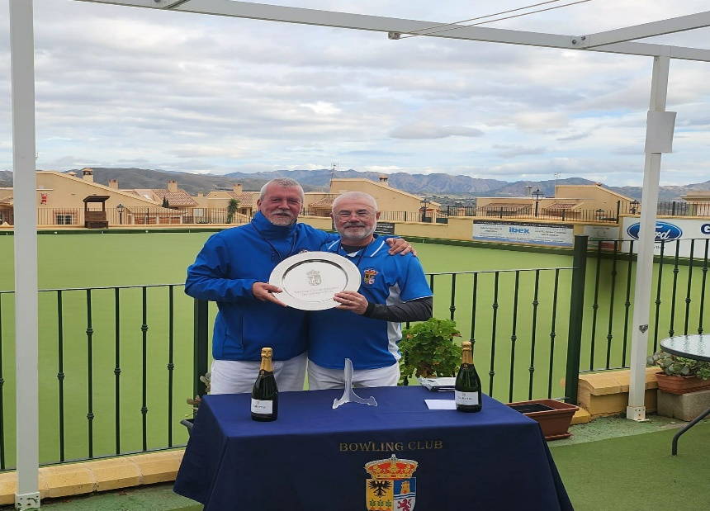The Alfoquia Plate Winners 2025

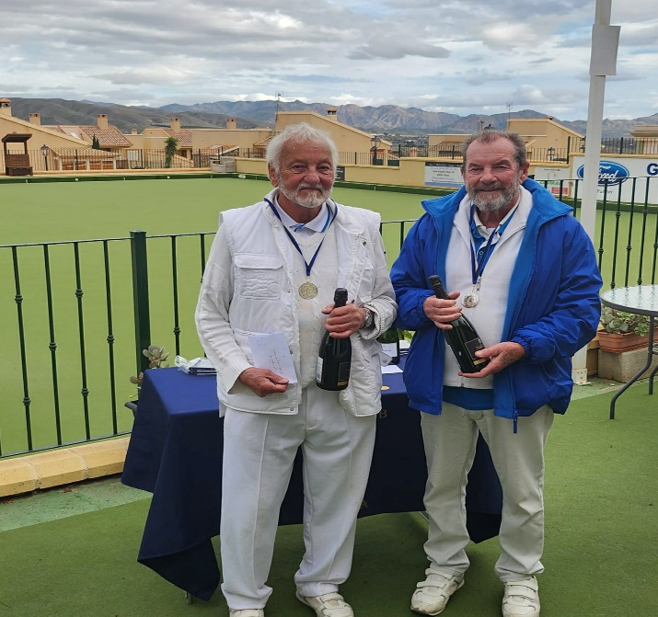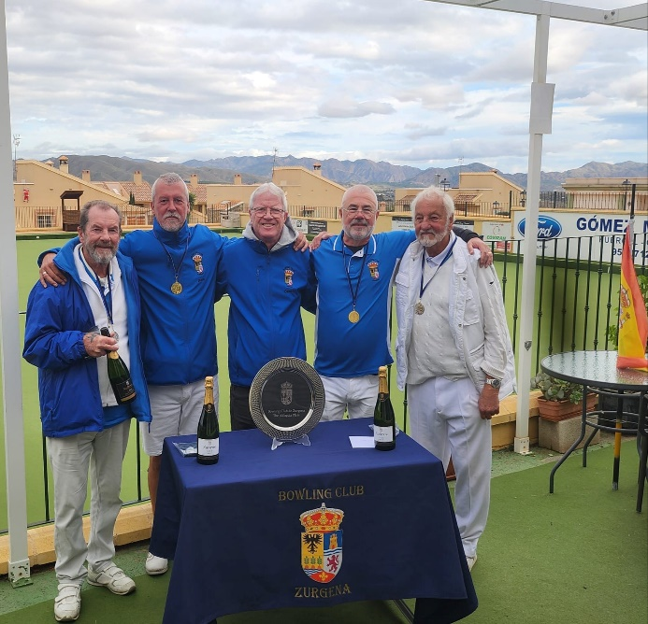
The Alfoquia Plate Runners Up 2025 The finalists and club Captain of the
Alfoquia Plate Competition 2025

CHRISTMAS MEAL 2025
Although we only had a third of the club at our Christmas meal at La Vida, Cucador, those that made the effort had a really good time We all enjoyed a good meal, plenty of wine and lots of dancing. Thanks go to Sharon at La Vida and her Staff for looking after us, John Slater a former member who entertained us, singing a variety of songs ensuring there was always someone up on the dancefloor dancing including a few ballads for those romantic couples. Thank you to our president Ade who gave a welcoming address to the members and their significant others, A big thank you goes to our Social Secretary Dez, ably assisted by Julie, for their hard work organising a very successful night. A final thanks goes to all our members for their support and the raffle prizes so kindly donated.

Photos of the Christmas meal
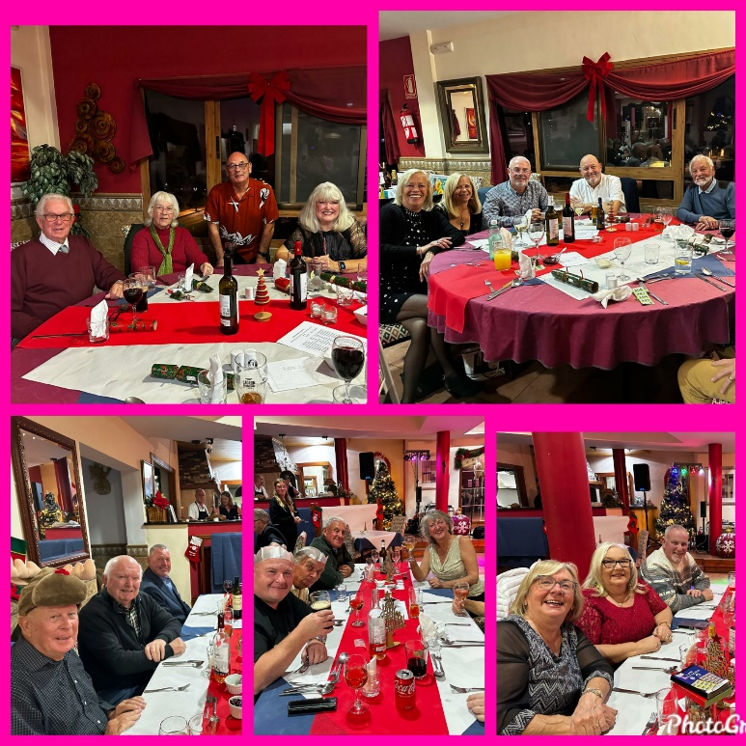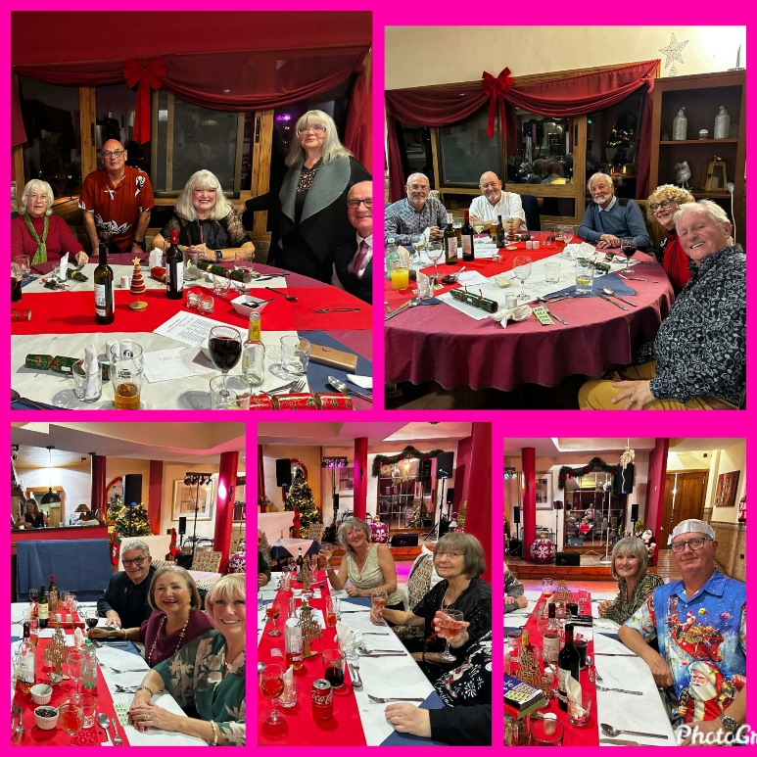
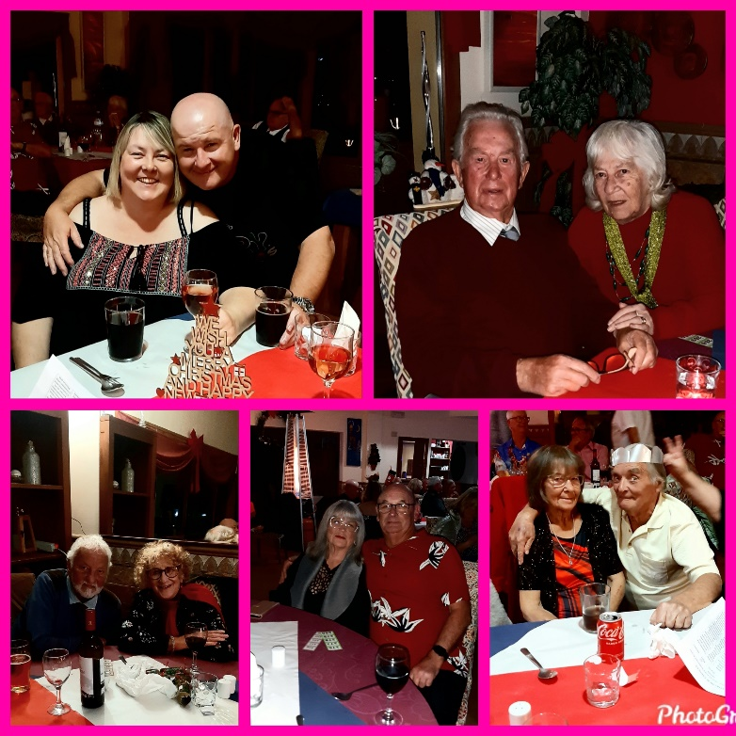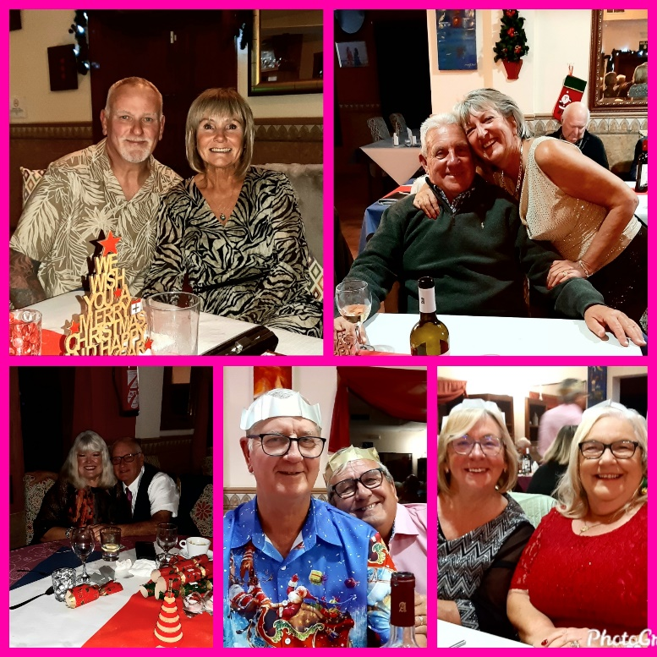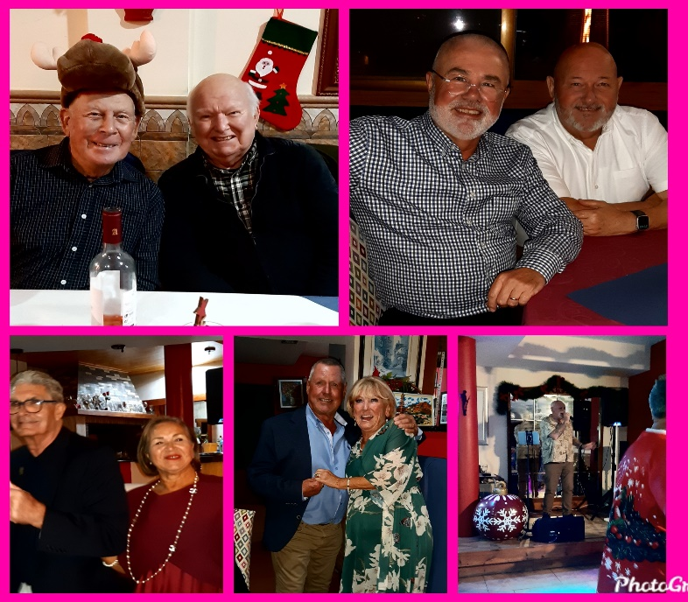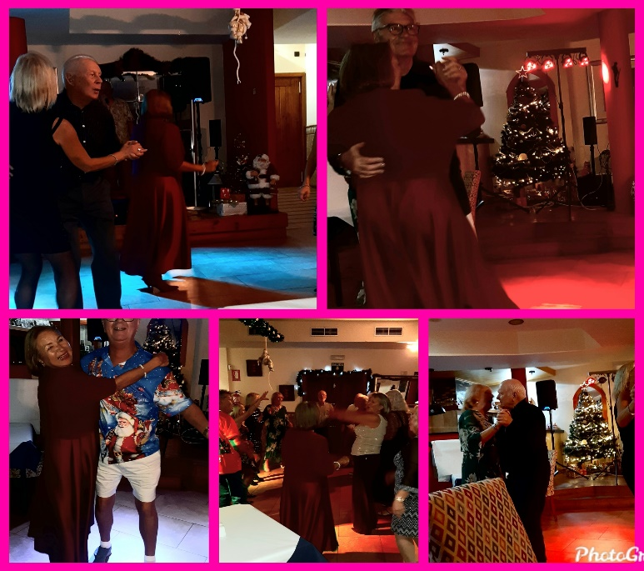

COMMITTEE NEWS
Following our AGM in January the current Management and General Committee were re-elected

NEW MEMBERS
Please give a warm welcome to Gordon and Doreen Blainey and Christopher Pardy who are new to bowling, and a welcome return to the club to Kevin McGowan, a previous member.

DATES FOR YOUR DIARY

8th -11th January 2026 FAB Rinks competition to be held at Indalo BC

Zurgena Singles League starts on Monday 19th January at 2pm
FAB Triples are being held at Zurgena BC on 29th Jan - 1st Feb

Turre Open 7-8th (Cabrera)

14th/15th February Spanish National Trials are being held at Indalo BC

19th – 22nd February Zurgena Mens & Ladies Pairs

26th February -1st Mar Zurgena Handicap Singles

.

